Question no.1:

Multiple choice question (MCQs)

1. What is the use of random signal?
2. Test dynamic response statistically
3. Time duration
4. Impulse response
5. **Both a, b.**
6. When we use DFT?
7. **When signal is periodic**
8. When signal is Aperiodic
9. Both a, b.
10. None of the above
11. What do you mean by aliasing in DSP?
12. Through which different signals become indistinguishable.
13. Distortion in the reconstructed signal when it is reconstructed from the original continuous signal.
14. **Both a, b.**
15. None of the above
16. What is microprocessor?
17. **Process control oriented tasks.**
18. High performance and repetitive
19. Intensive task
20. All of the above.
21. What is convolution?
22. Technique of adding two signals in time domain.
23. Through FFT it is easy to change domain.
24. **Both a, b**
25. Technique of adding two signals in frequency domain.
26. What is FFT?
27. Fast way to measure DFT.
28. It is much efficient then DFT.
29. This technique is feasible.
30. **All of the above**
31. What is the advantage of a direct form II FIR over form I?
32. **Requires half the number of delay units.**
33. It is in
34. Both a, b
35. None of the above
36. What is interpolation?
37. Decreasing the sample rate in DSP.
38. **Increasing the sample rate in DSP.**
39. Same as Decimation
40. All of the above
41. How many complex multiplications are required to compute X (k)?
42. N2/2
43. **N(N+1)/2**

The total number of complex multiplications required to compute N point DFT by radix-2 FFT is?

________________________________________________________

Question no.2:

**Classify the following signal if it is power signal.**

Solution:

We are taking T in between 0 to 2

Solving the integral, respectively.

Where

Power signal becomes,

Solve it further, we will get

P=0.2499999 this value lies in between, so it is a power signal.

___________________________________________________

Question no.3:

**Use the graphical interpretation of convolution to find the output y[n] for the input x[n] and impulse response h[n].**

**It is important question!**

__________________________________________________________

Question no.4:

**Find the linear convolution between**

**Solution:**

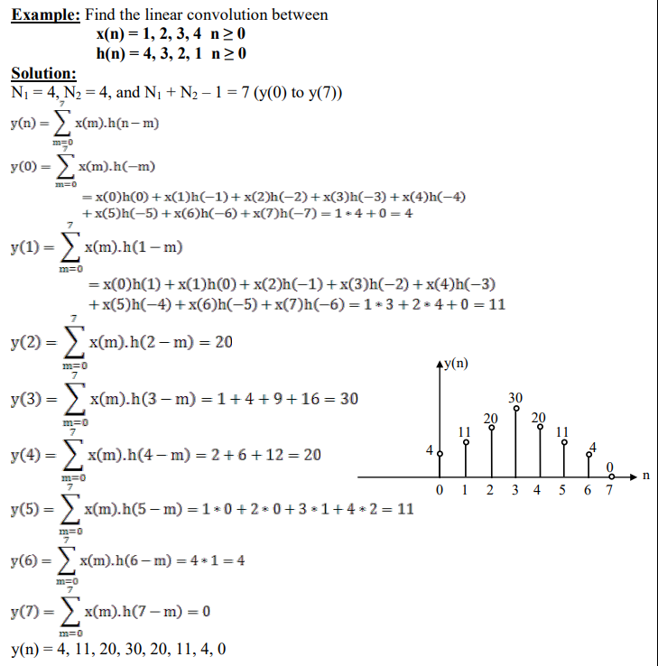

__________________________________________________________

Question no.5:

Find the circular convolution between

Solution:

